Kotis Pocket Application Guide

Reference Support team guide for Pockets for all the steps before KPS.

Safety

Please be aware of safety guidelines of all machines used in this guide. The cutting blade is sharp, the creaser is hot and the embroidery machines have sharp moving parts.

Tools

Embroidery machine and hoops , creaser machine, large paper cutter, [Brown creaser paper](https://www.amazon.com/gp/product/B004NEW94E/ref=oh_aui_detailpage_o06_s00?ie=UTF8&amp&psc=1), [E-Zee Tear 1.8 oz. Waffle - Pop Away](http://www.madeiramart.com/index.cfm?fuseaction=ezeebacking.detail&productgroup_id=232), 7.25” Mighty Hoop, Cover Stitch Sewing Machine, matching embroidery and sewing thread.

Standard Process: Example PO 237825 - Drake's Brewing | Fing Raccoon Pocket Tee

(If you are looking for the pocket prep guide, follow this link)

1. Pre-Production Check: PO must call out thread color desired for pocket application. **Do not assume grey outline of stitches on digital proof is the color they want. This is an opaque guide outline to represent stitches and doesn’t always match the color they pick.**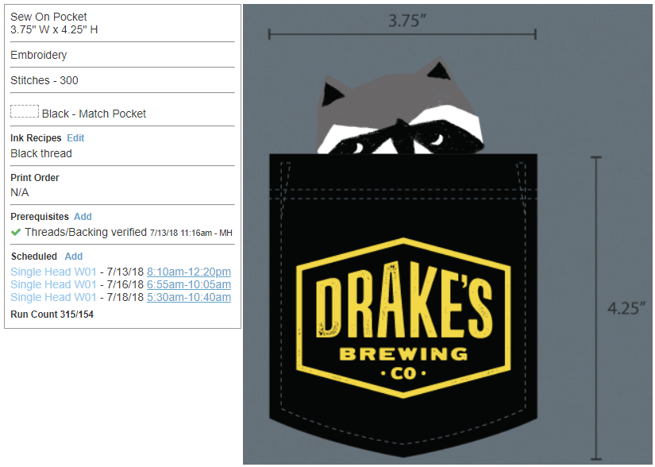

**^See how grey stitch lines do not reflect their desire to have black thread as called out.**

Examples of correct versus incorrect pocket callouts:

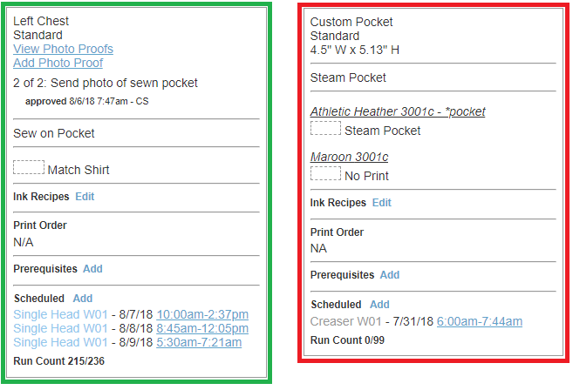

It should say “Match Shirt” or “Match Pocket garment” pick thread that matches the base color of the garment or the production location must clearly call out a specific color. If it says “Match Garment” that is not clear enough. If it has no color called out, this is also unclear.

1. Make sure that both the screenprinting and embroidery photo proofs are approved before beginning any sewing steps.

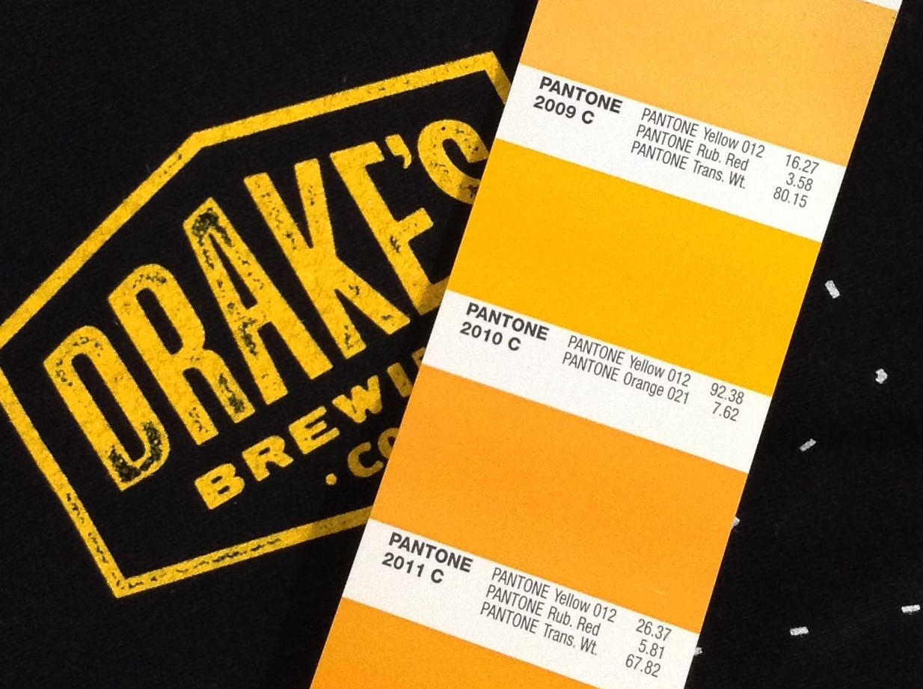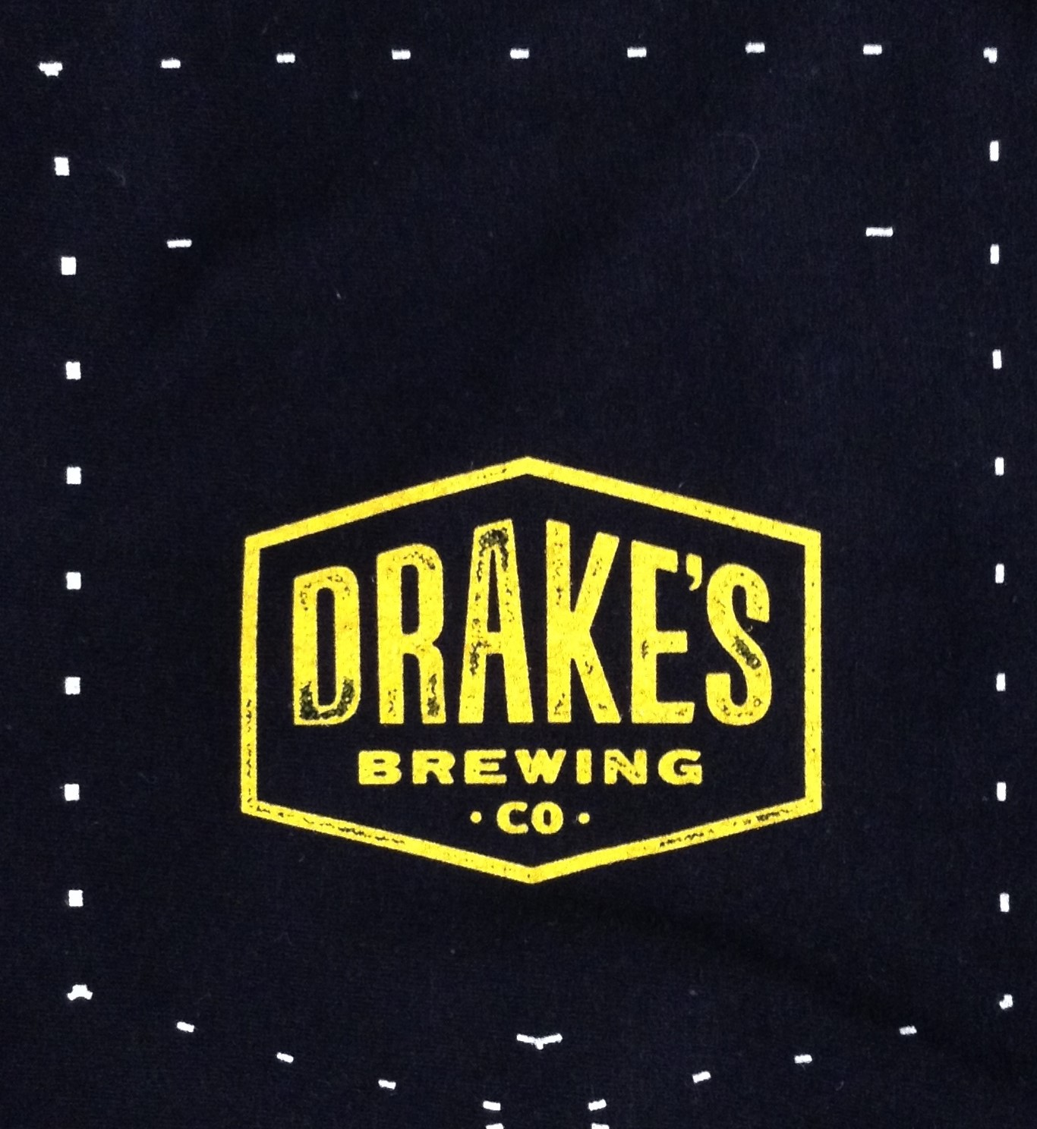

This is examples of screen printing’s photo proof. They should be printing the outline of the pocket for cutting purposes and the two dashes to show where to fold the pocket for the cover stitch.

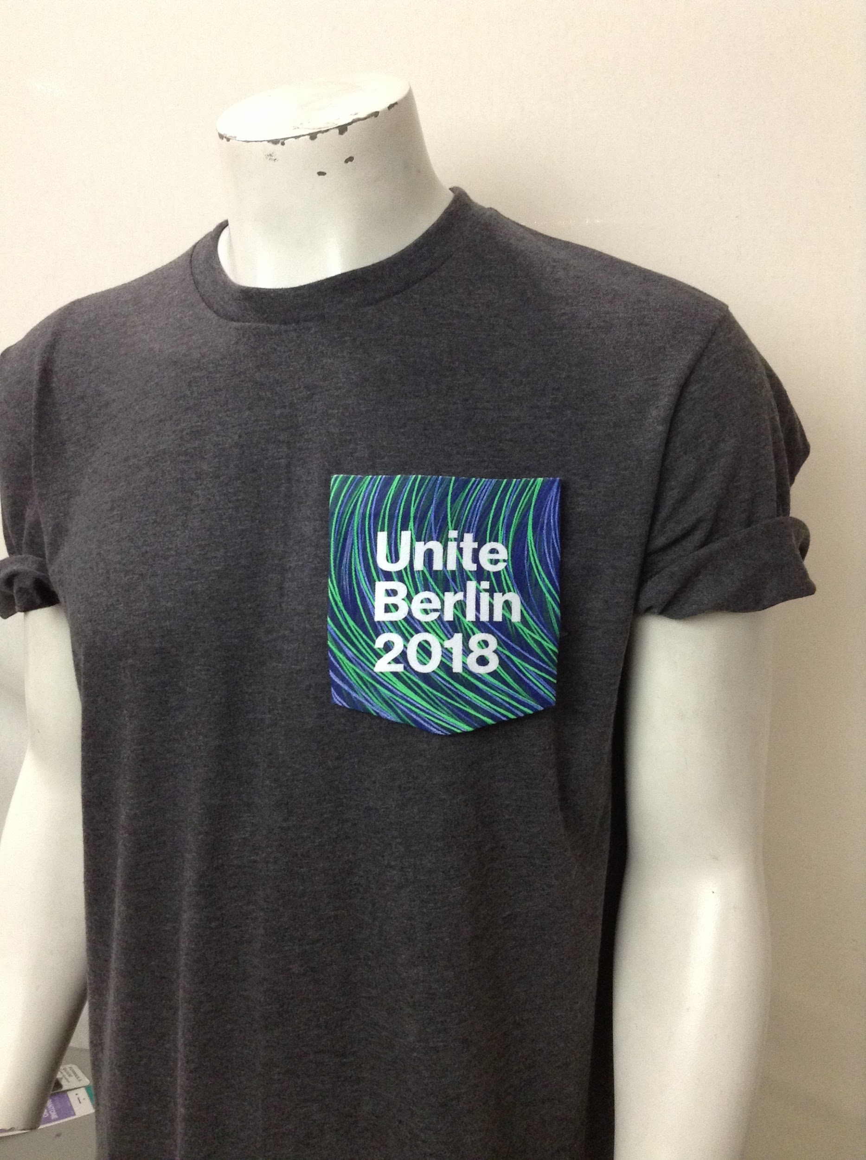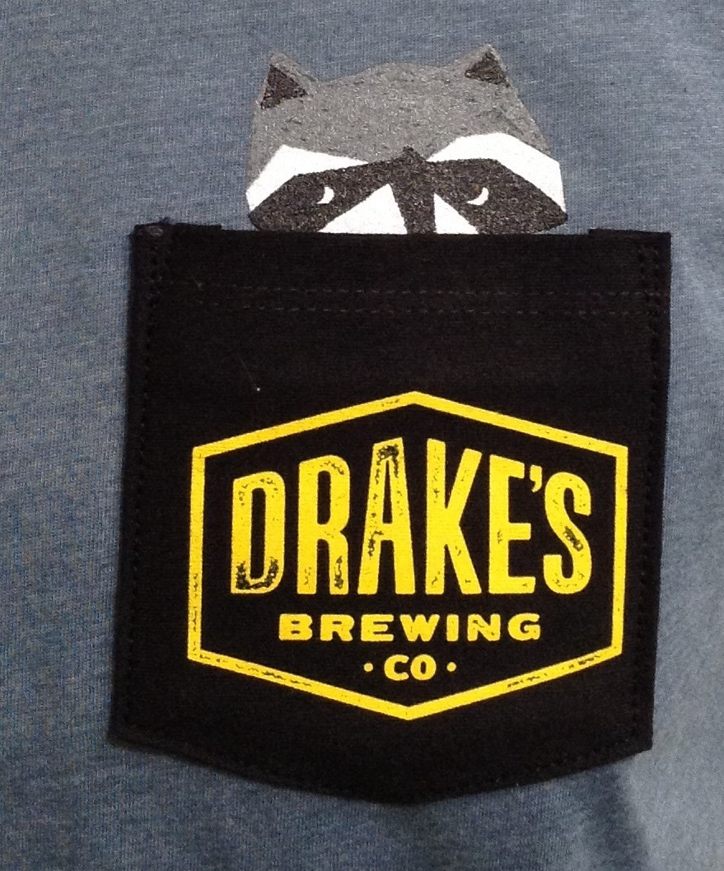

It’s important to show in the photo proof that the pocket lands in the same place as the digital proof if there is a image printed under the pocket, as well as, it looks placed right on the mannequin form.

1. Target timing 30 sec per pocket

Key Tips on Cutting:

Red lines show targeted places for cutting.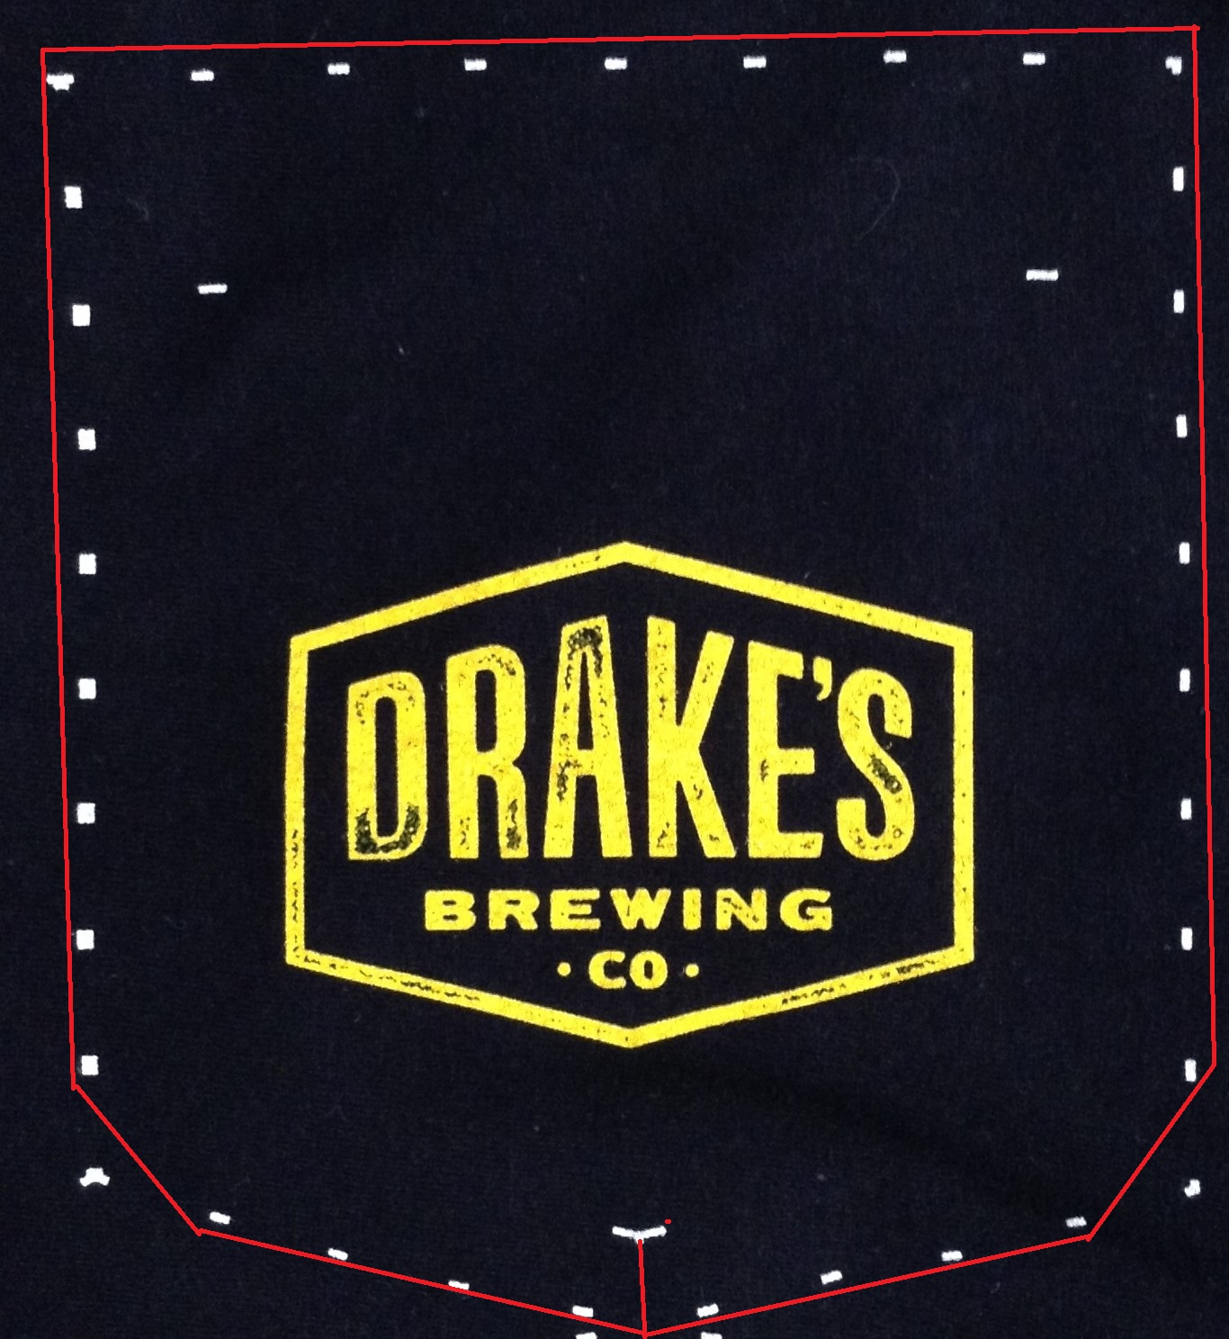

Its ok to cut directly on top of the dotted lines, slightly inside of them or slightly outside of them. If you leave too much outside fabric, the creased pocket will feel bulky, if you cut too aggressively, the fabric might not have enough to fold under for the hem allowance.

Don’t forget to cut the edges of the corners to reduce bulk after creasing.

Cut a single snip from the bottom to the “whale’s tail”.

4) Key Tips on sewing:

Red line shows where to fold fabric before coverstitching.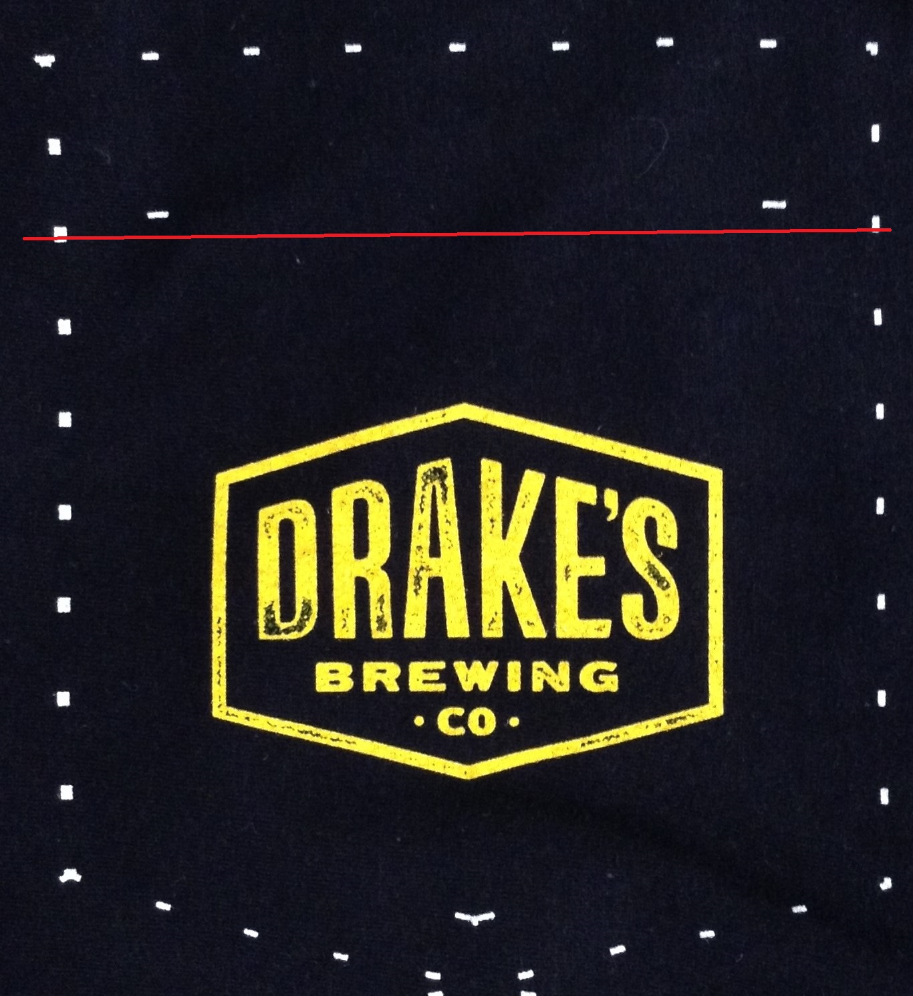

Crease under markers so the client does not see the lines on the outside facing part of the pocket.

Cover stitch all the pockets in one go and then cut them apart for next step.

If shirt is stretchy and you can tell the design got printed crooked, this is the step where you might try to fix the slant by sewing the pocket top parrallel with the logo instead of sticking to the the screen printed marks.

Key Tips on Creasing: 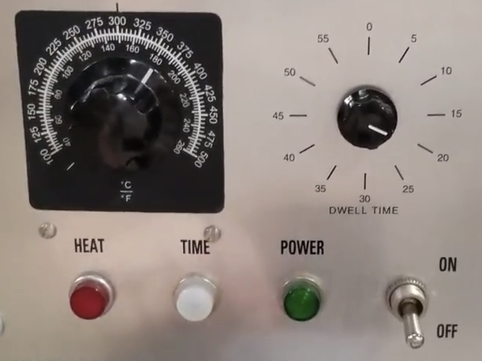

If the Creaser is too hot the ink will stick to the brown paper. If the Creaser is too cold, the folds will not hold once the paper is removed. Turning the temp up and reducing the length of the press or visa versa might help reduce challenges with pressed the pockets.

355º C or 180º F temp and press for 20 sec is standard.

Creaser needs at least 15 min to fully heat up all the way when you start.



Although hot, the brown paper is enough to protect your hands as you slip the brown paper and pocket into the creaser plate.

The bottom flap holds the pocket “sandwich” together while it is pressed.

The creaser plate has markers drawn onto it to help you target the height of the pocket. Above the red lines makes the pockets too tall and the “whale’s tail” will show on the front of the pocket. The black marks shows the absolute shortest we can go before the pocket is too short. Target between the two marks for best results. You want both edges of both sides to me the same height on the creaser plate of the pocket will crease lopsided.

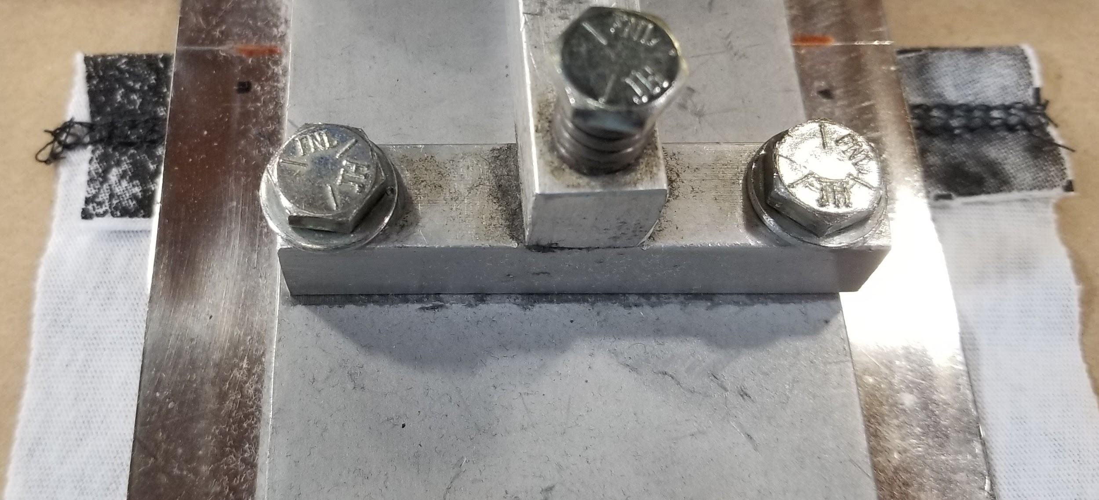

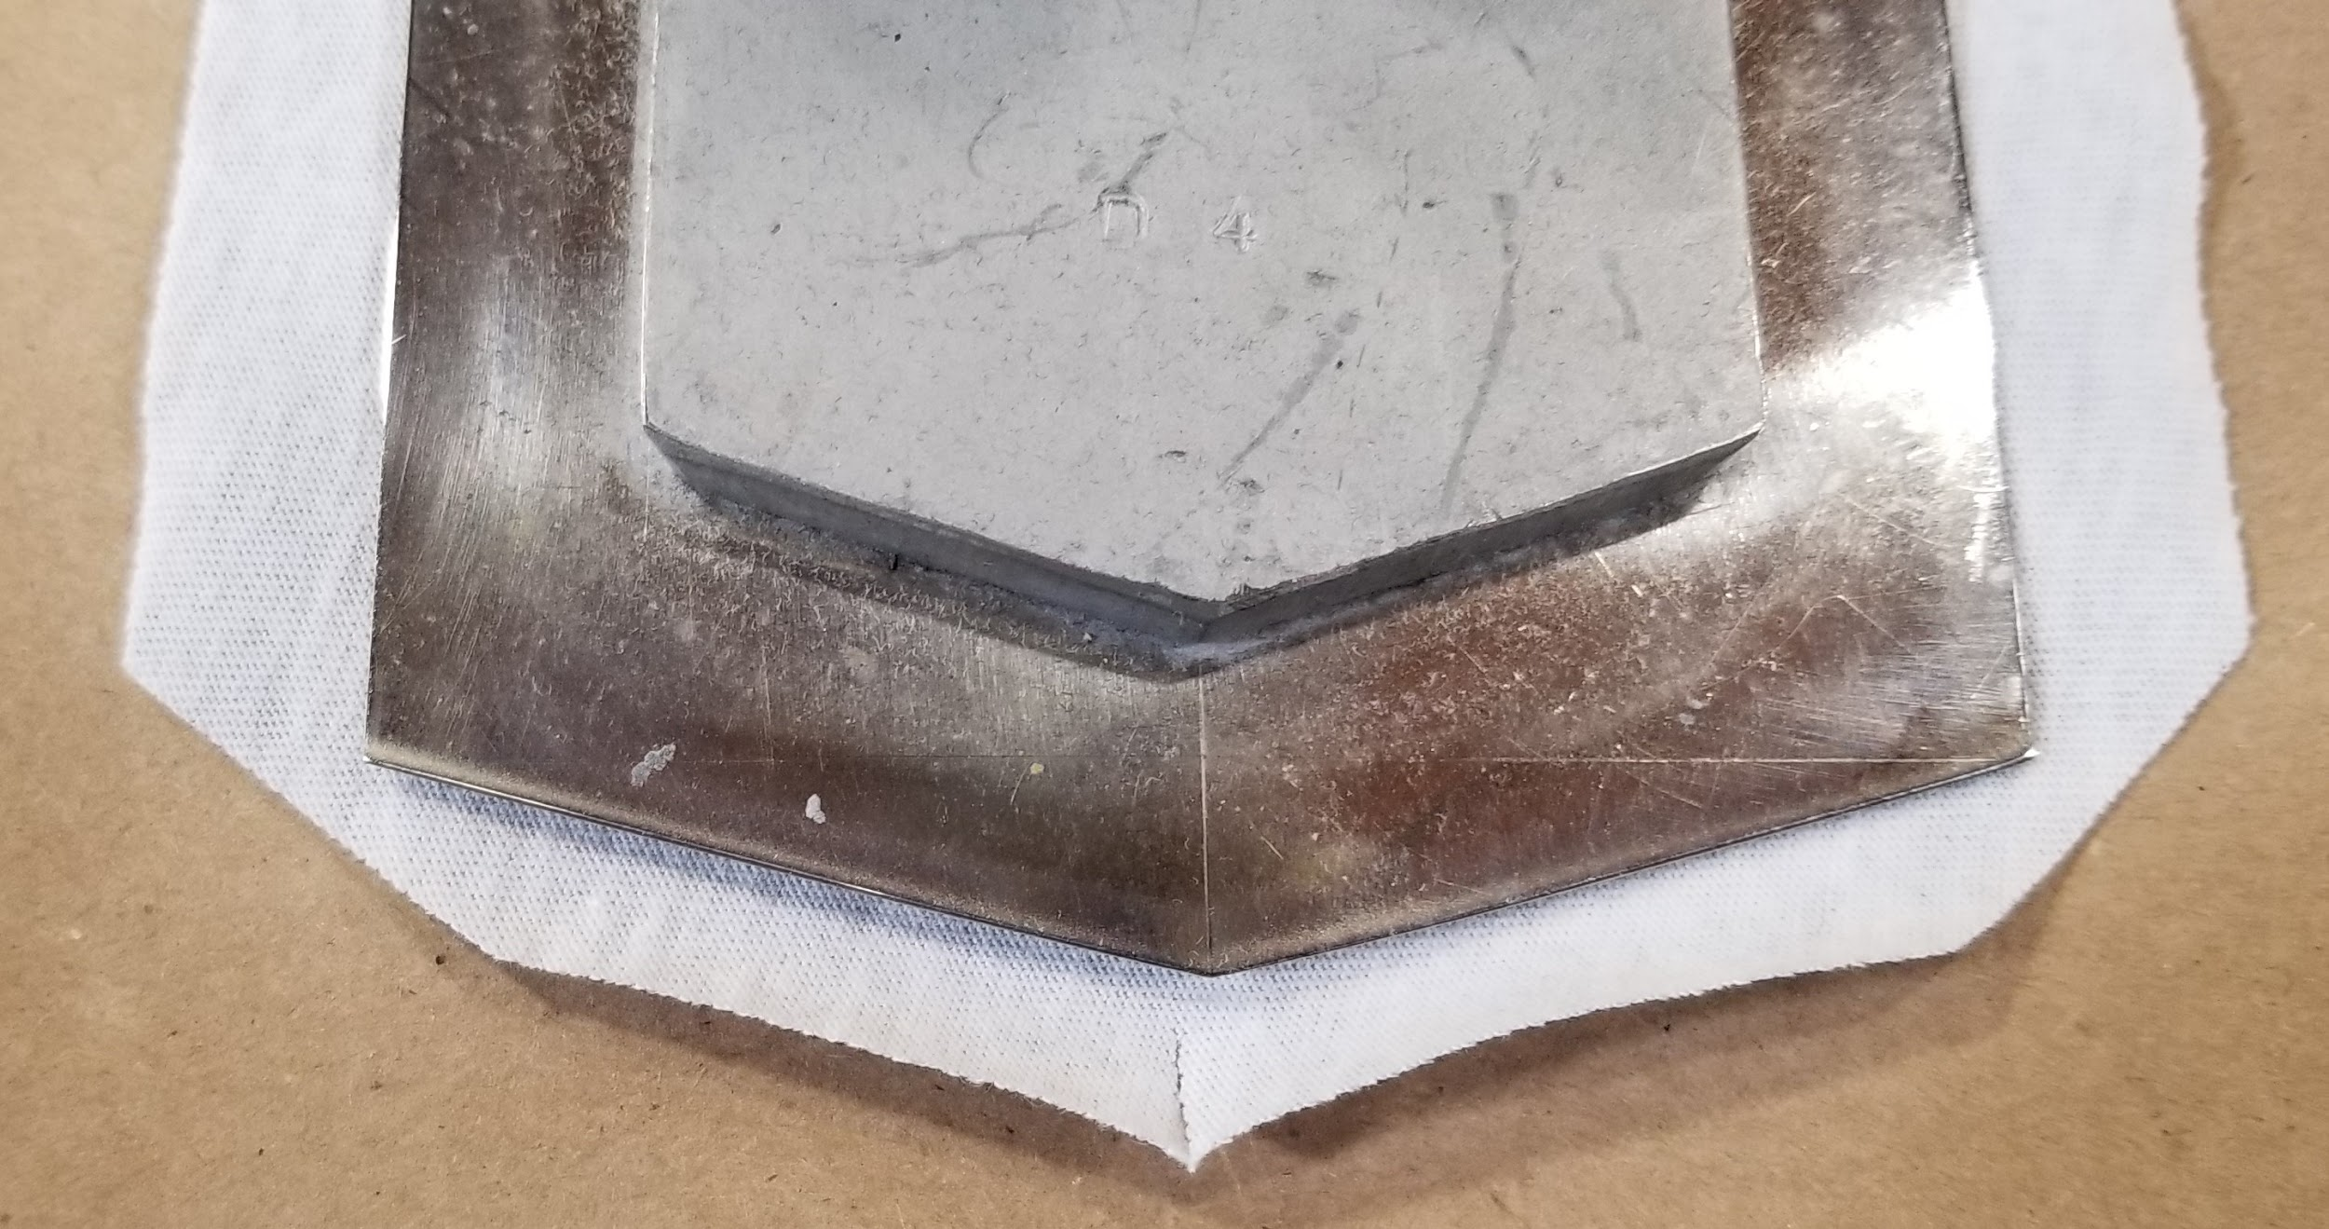

The bottom of the creaser plate should be surrounded by pocket fabric. 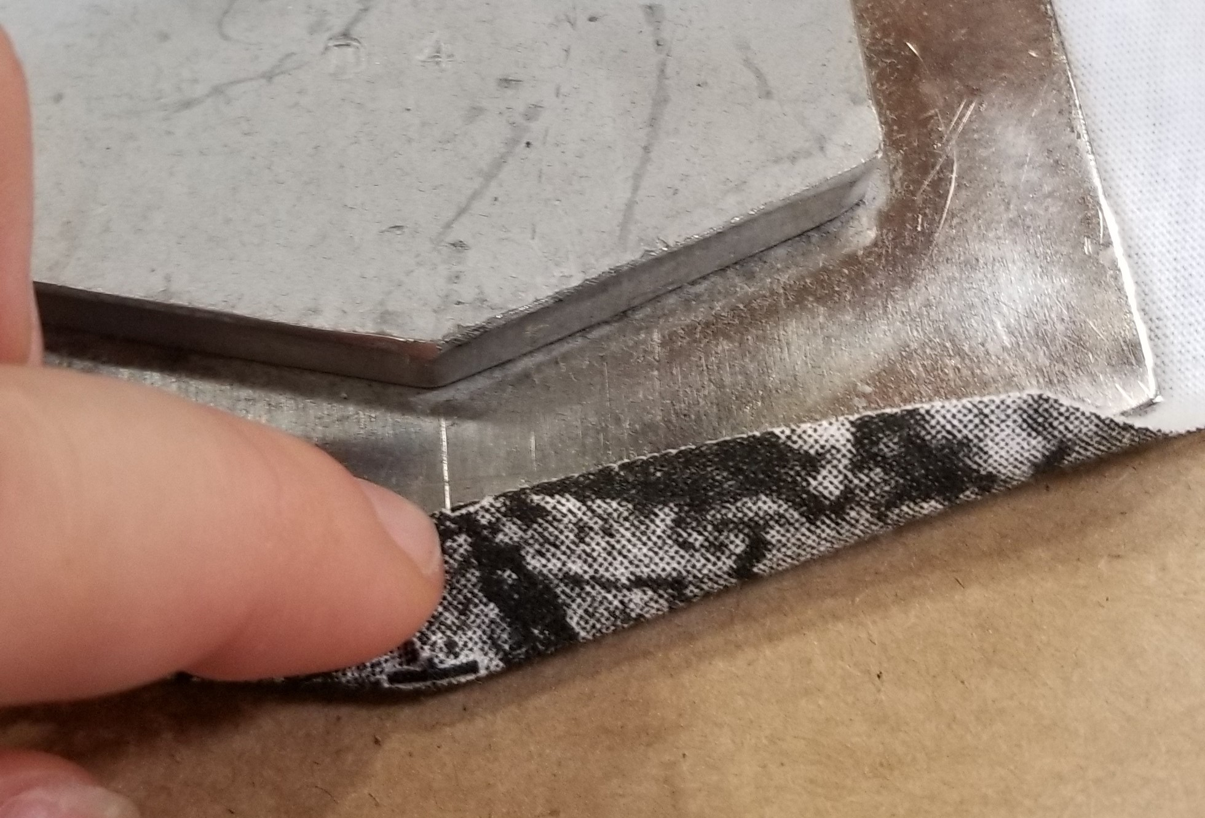

The “whale’s tail” must be past the tip of the creaser plate. If it shows on the front of the pocket, it is not good. Pocket fabric should extend past the bottom corner of the creaser plate on the sides as well.

QCing Creased Pockets:

Ink melting

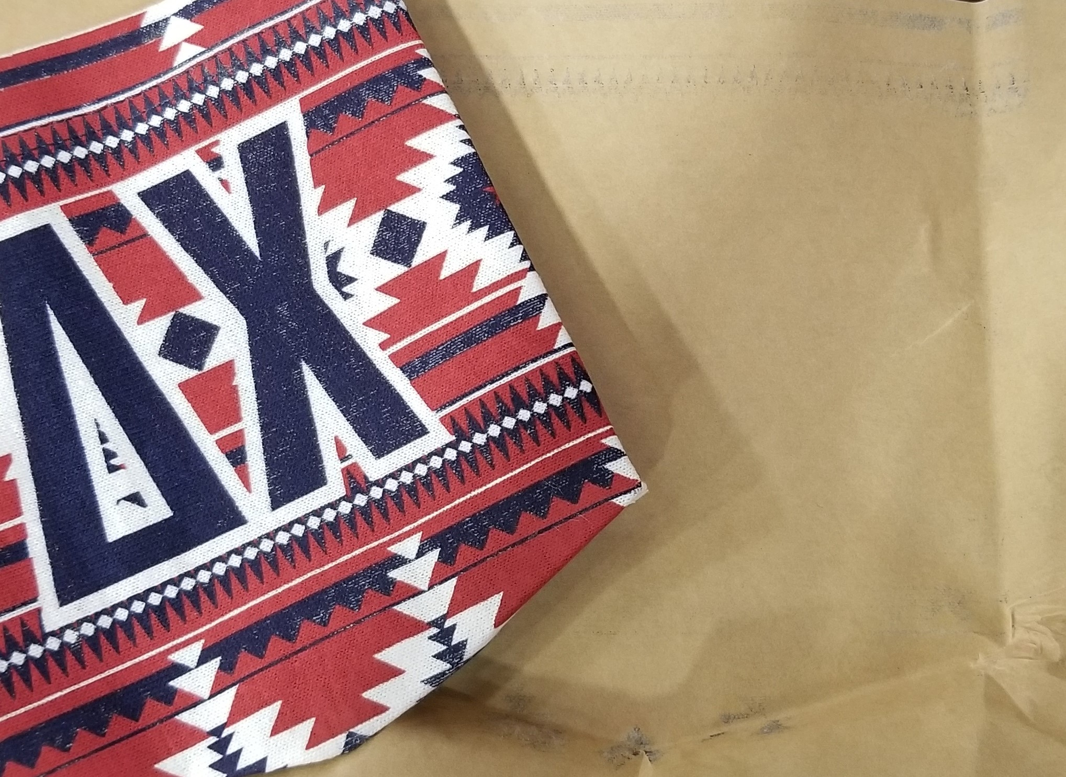

If the Ink is applied too thickly, or the creaser is heating up too hot - the ink might melt and stick to the brown paper. As seen above the Navy ink is sticking to the paper and looks distressed. This pocket is unacceptable - throw it away.

Off center

We want the logo centered on the pocket. If the design is off centered, you can re-crease the pocket in the creaser. Peeking under the bottom tip to see if the “whale’s tail” is directly under and centered to the tip of the creaser plate is an easy way to verify you are on track.

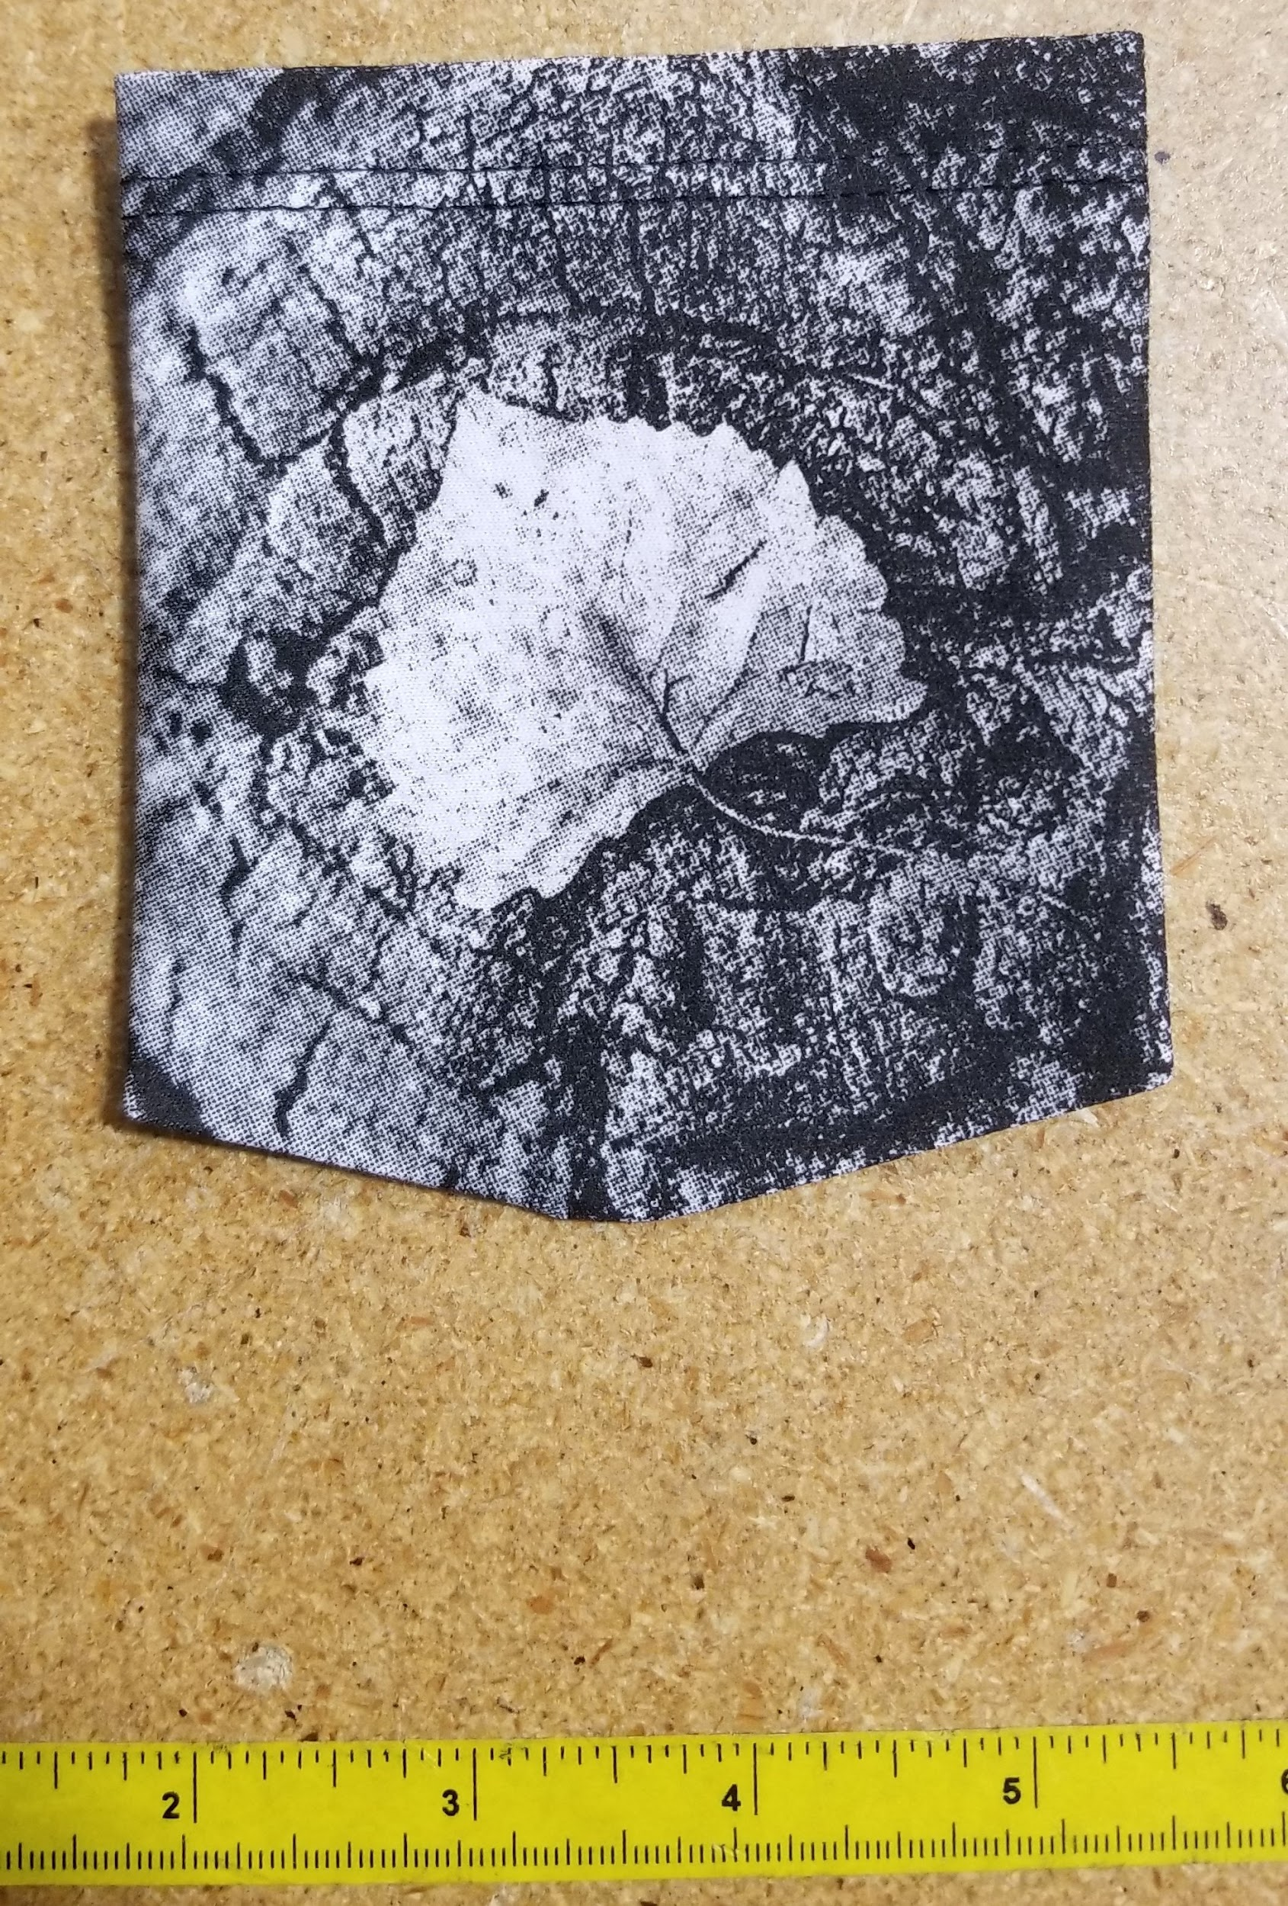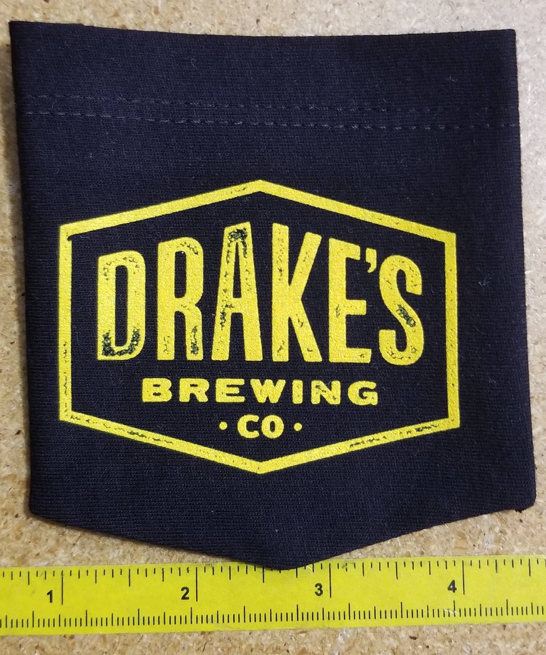

Aggressive cutting on edges of the pocket or up past the “whale tail” will ruin a pocket.

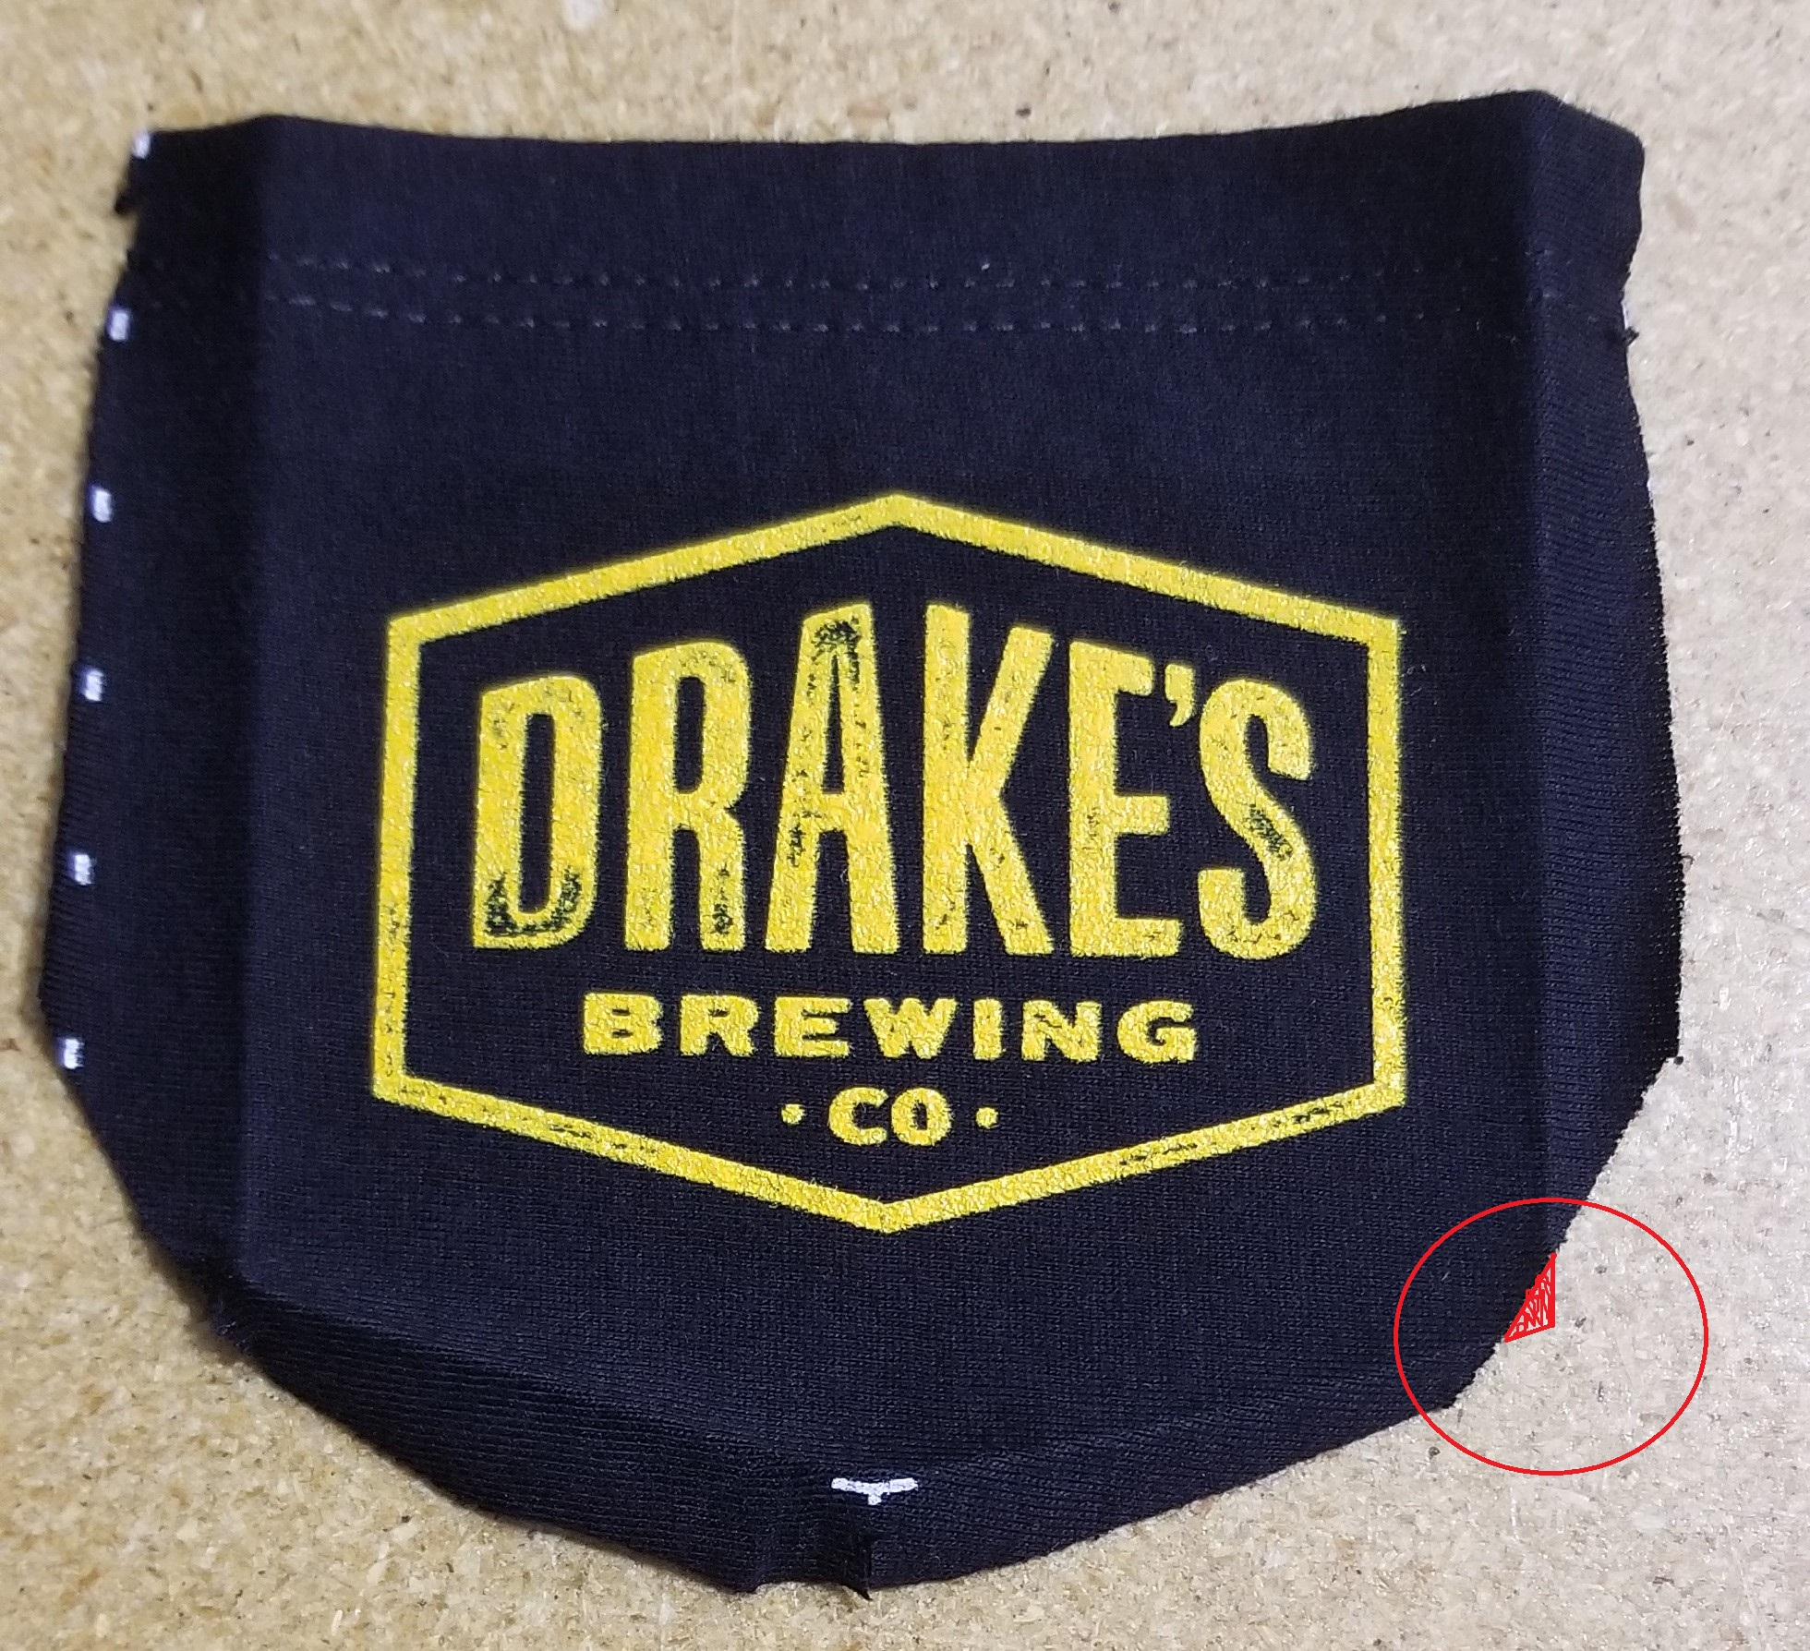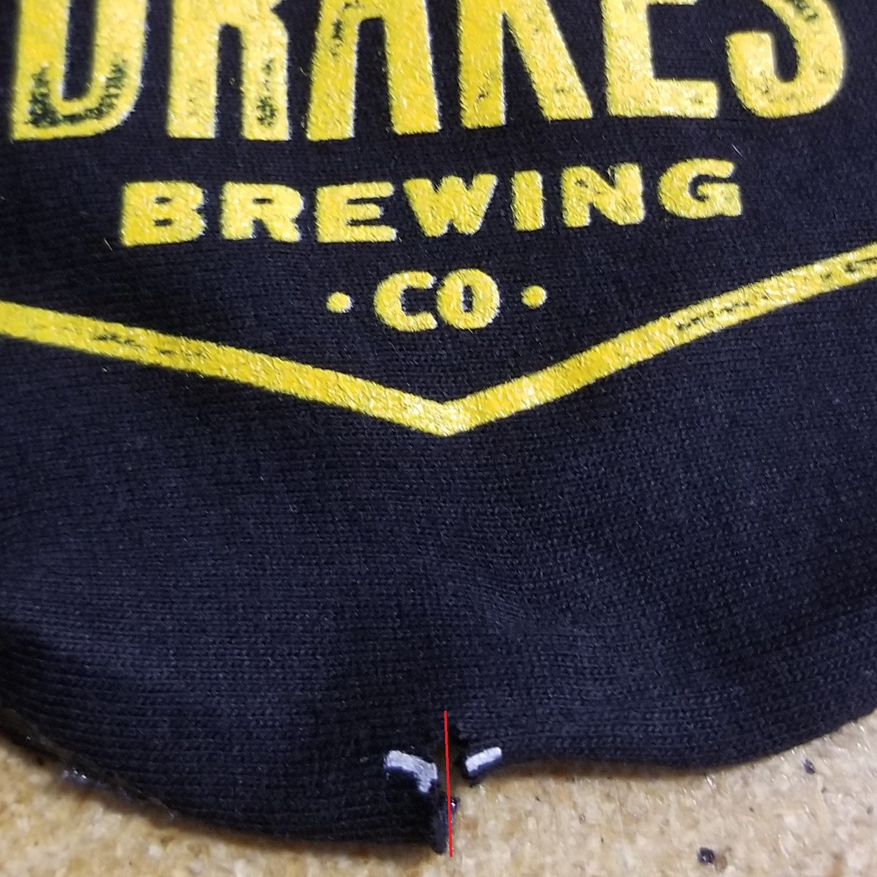

Throw pockets like this away.

[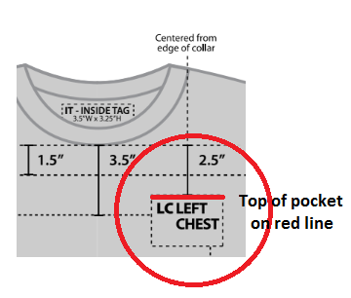](https://youtu.be/_2GVGWVAlSo)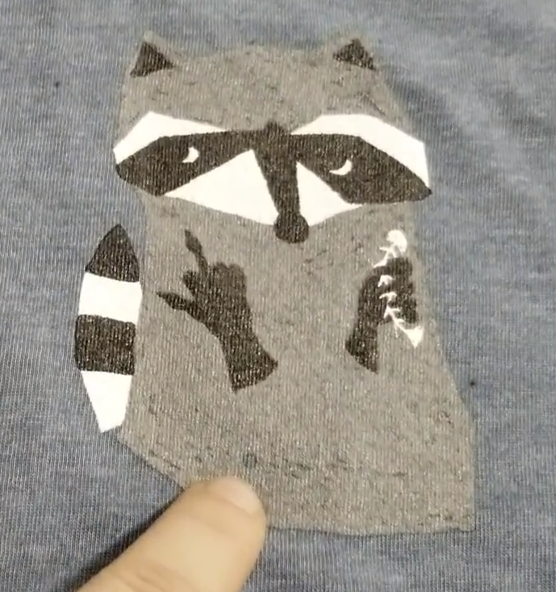

Pocket placement is 2.5 inches from the bottom of the collar should be where the top of the pocket falls. If screen printing has decorated the area under the pocket, they will have a marker in the print for us to line the embroidery needle to as center. See Raccoons belly button in above photo. **If the pocket involves centering on a screenprinting design, USE THE WHITE HOOPS.** Even for smaller pockets. This will give you the freedom to center each shirt without accidently hitting the frame.

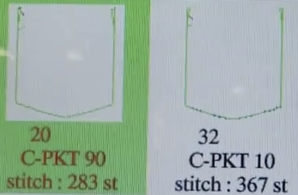

Small pockets:

283 stitches; 90x100; 3.75" W x 4.25" H

Standard Pocket:

367 stitches; 109x124; 4.5" W x 5.13" H

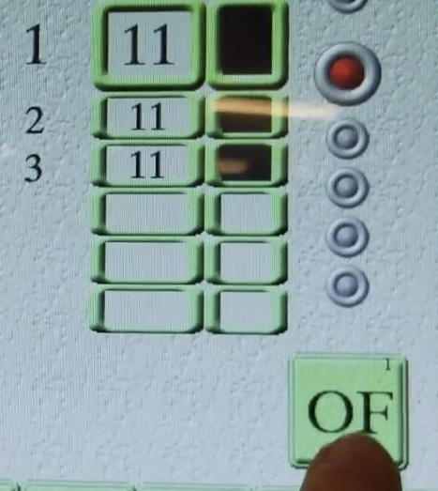

The embroidery file must have a programed stop between color 1 and 2. This allows it to stitch the outline down and then pause for the operator to apply glue and place the pocket on top of the shirt.

The red bubble lit up like so (picture left) indicates that at the end of color 1, the embroidery machine will pause. Activate and deactivate this by pushing “OF” when the machine is targeting the color step 1 on the thread color selection screen. (Watch video for more explanation)

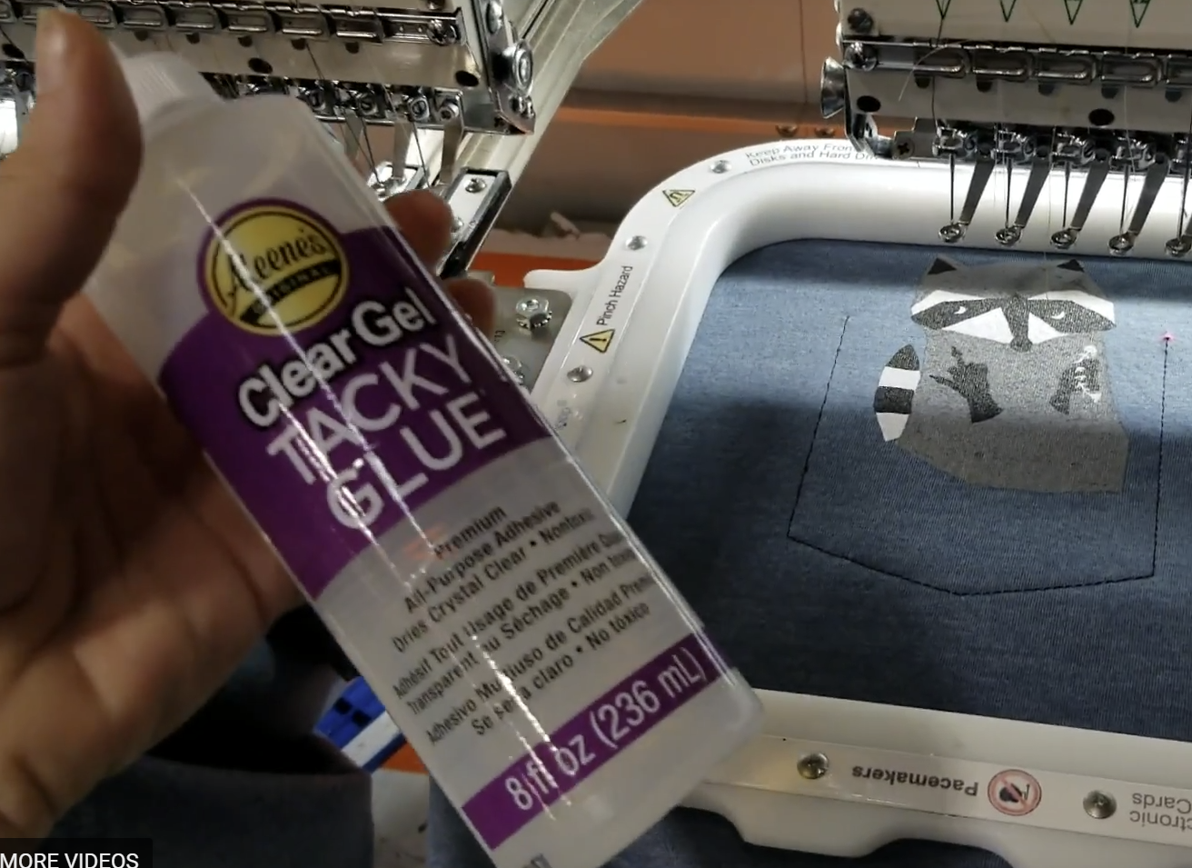

Tacky Glue is best for holding the pocket in place while the machine stitches it down. Buy at [Joanns](https://www.joann.com/aleene-s-quick-dry-intackyin-glue/7312416.html#start=1) or on [Amazon](https://www.amazon.com/gp/product/B0018NA0F8/ref=oh_aui_detailpage_o00_s00?ie=UTF8&amp&psc=1).

Place glue on inside of pocket outline. Too much glue will clog up needles and cause thread breaks.

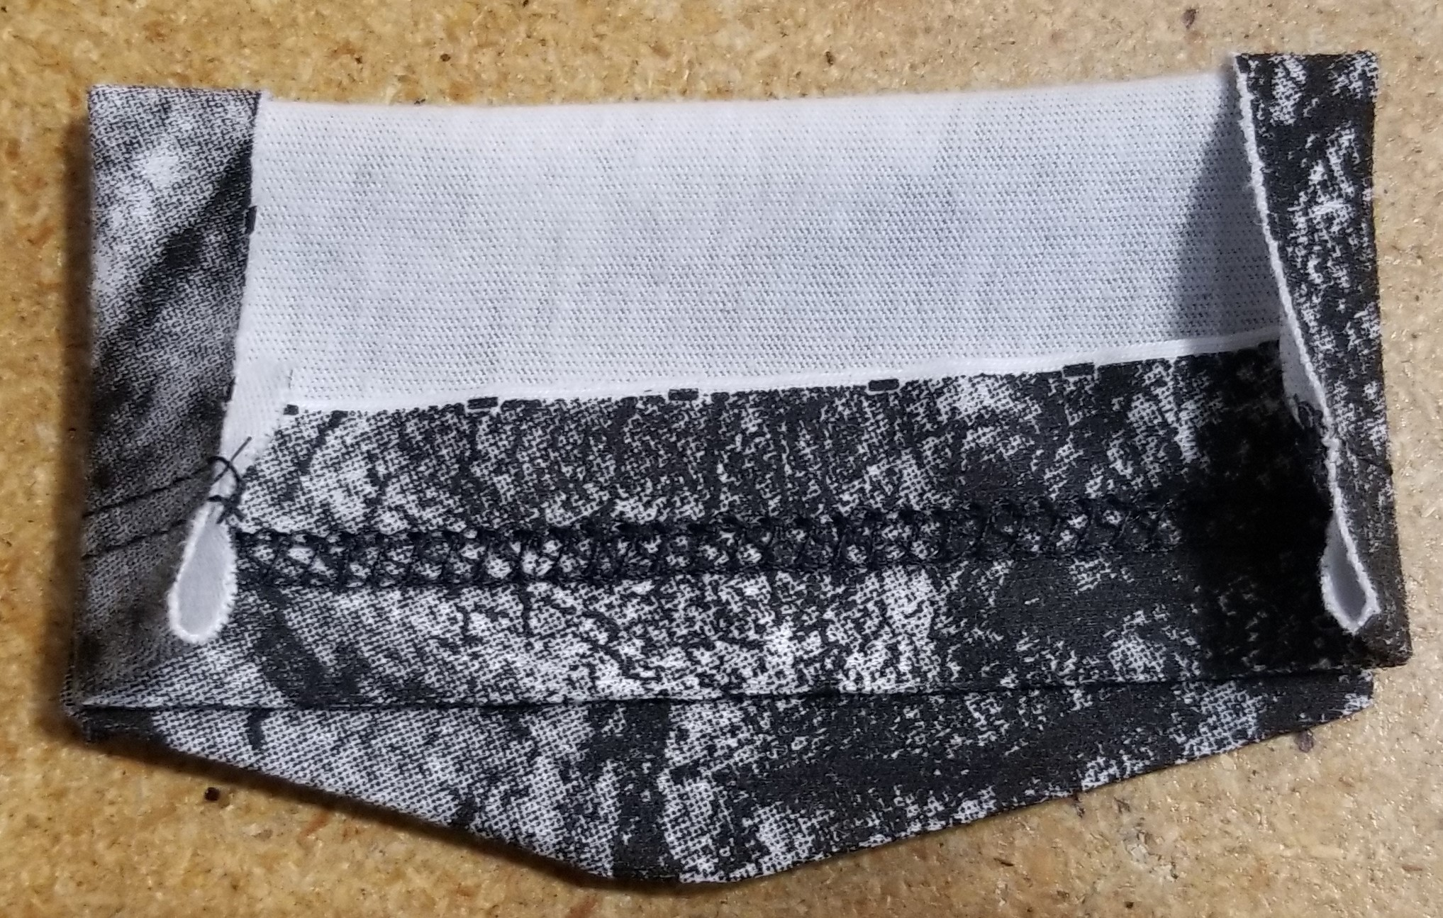

We have found that folding pockets like this and stacking them one on top of the other, keeps them well presses, organized and easy to apply.

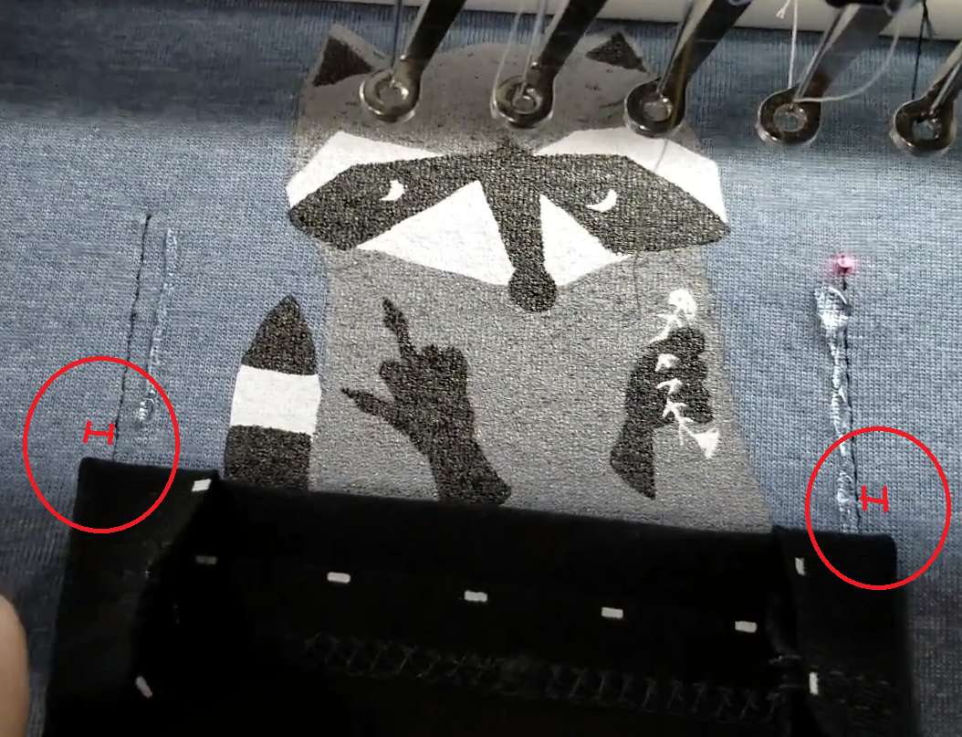

The pocket should be placed with equal overhang of the pocket to the outline stitch on either side. If you have one side with more space than the other, the pocket will look off centered. The pocket needs to fully cover the outline stitches or it will not be stitched down properly.

1. Pocket clean up: Tear the waffle pop backing out from the inside of the shirt. (Review cleaning embroidery document) Trim any inner strings that are more than .25 inch long. Stack by size in bundles of 10 and box PO. Do regular QC process (support team doc)for all garments to ensure the placement is consistent, the thread and ink colors are the same through whole order and garments look presentable as unboxed.